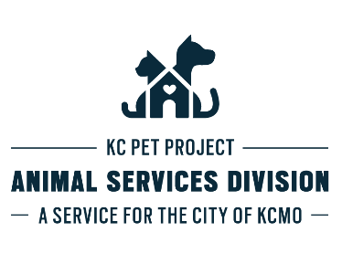
Application for Breeding & Show Dog Exception
Pursuant to Section 14-60 of the Kansas City, Missouri Code

Name: __________________________________________________________________________ Date: __________________________________
Address: ________________________________________________________________________________________________________________
Phone Number: ________________________________________________ DL or SS#: _________________________________________________
DOB: __________________ Sex:___________________ Race:_________________________ Eyes: __________________ Hair:________________
Dog’s Name: ____________________________ Sex: _____________ Color:__________________ Dog’s DOB: _____________________________
Breed: A.P.B.T. A.S.T A.B. Other
Dog’s License Number: __________________________________________________ Expiration Date: ____________________________________

The applicant has submitted the appropriate forms and fees required by Department in order to seek consideration for a breeding permit. | Pass | Fail
Premises inspected and the Department is satisfied that the applicant has a space in which to breed pit bulls and will contain the animals as well as provide them with safe, sanitary and humane conditions, appropriate for breeding pit bulls, which satisfies all applicable provisions of Section 14-60 of the Kansas City Municipal Code. | Pass | Fail
The Department has evaluated and reached a positive conclusion regarding the suitability of the particular pit bulls to be bred, including consideration of their lineage, age and health condition. | Pass | Fail
Verification that the pit bull to be bred is registered as an American Pit Bull Terrier, an American Staffordshire Terrier, a Staffordshire Bull Terrier, or an American Bully with the appropriate registry for its breed (American Kennel Club, United Kennel Club, American Dog Breeders Association (“ABDA”), American Bully Kennel Club (ABKC)) or any other valid registry as determined by the Department. | Pass | Fail
The registered pit bull has participated in at least one approved dog show during the previous 365-day period or the owner, guardian or keeper has given written notice to one of the dog registries listed above stating his/her intention that the dog will participate in an approved dog show. A dog show is defined as an event that is sanctioned in writing by one or more of the dog registries listed above. | Pass | Fail
Dog has had the appropriate health screenings and temperament test. | Pass | Fail

Yes | No | Orthopedic Foundation for Animals (OFA) or University of Pennsylvania Hip Improvement Program (PennHIP) certification on hips | Pass | Fail
Yes | No | OFA on heart by a certified cardiologist | Pass | Fail
Yes | No | American Temperament Testing Society temperament test. | Pass | Fail
Yes | No | Dog has had a litter in the last twelve (12) months. | Pass | Fail
Yes | No | The applicant paid the permit fee within two weeks of notification that the application has been approved. | Pass | Fail
Yes | No | The applicant has a history of allowing dogs to run loose or escape, or has otherwise been foundto be neglectful, has had his/her dog identified as a nuisance, or has previously been determined to have violated applicable areas of Section 14-60 of the Kansas City Municipal Code. | Pass | Fail
Yes | No | Applicant has applied for a permit within the last ten months. | Pass | Fail

Permit Granted: Yes___ No____ Date:___________________ By: _____________________________________________________________
Fee Pending: _____________________ Fee Paid:________________________

Comments: ________________________________________________________________________________________________________________________
________________________________________________________________________________________________________________________
________________________________________________________________________________________________________________________
________________________________________________________________________________________________________________________
________________________________________________________________________________________________________________________

APPLICATION MUSH BE RETURNED WITHIN 30 DAYS OF COMPLETION.

